AI-Based Student Support Assistant using Dialogflow
Name: K. Pavan Kumar
Registration Number: 192524333

1. Problem Analysis and Agent Design
Objective: Develop a Dialogflow chatbot to answer queries on course registration, timetable, exams, attendance and campus services.
Users: Students.
Environment: Dialogflow Essentials.
Inputs: Student queries.
Outputs: Chatbot responses.
Performance: Accuracy, response time and usability.

2. Dialogflow Agent Development
Created intents: Course Registration, Time Table, Exam Schedule, Attendance, Campus Services. Added training phrases and responses. Used Default Welcome and Fallback intents.

3. Problem Formulation and Decision Flow
Start → User Query → Intent Matching → Appropriate Response → End. If no intent matches, Default Fallback Intent responds.

4. Search Strategy Application
Dialogflow uses intent matching similar to heuristic search by selecting the closest matching trained intent.

5. Testing and Evaluation
Tested with queries: Hi, Course registration, Show my timetable, Exam schedule, Attendance, Library. All configured intents returned expected responses.

Implementation Screenshots
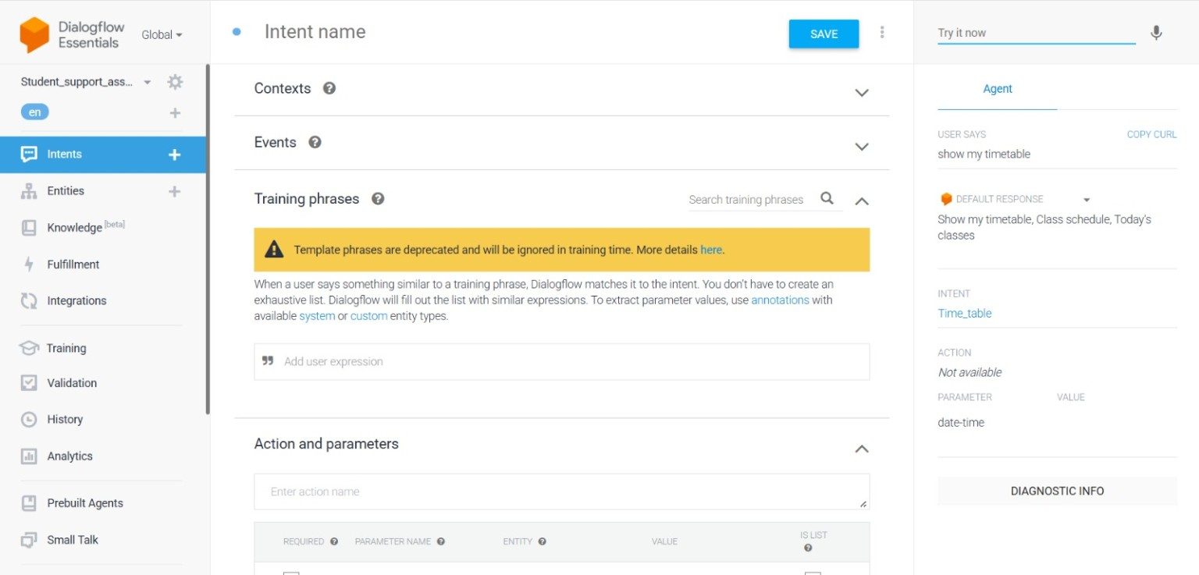
Figure 1: Course Registration
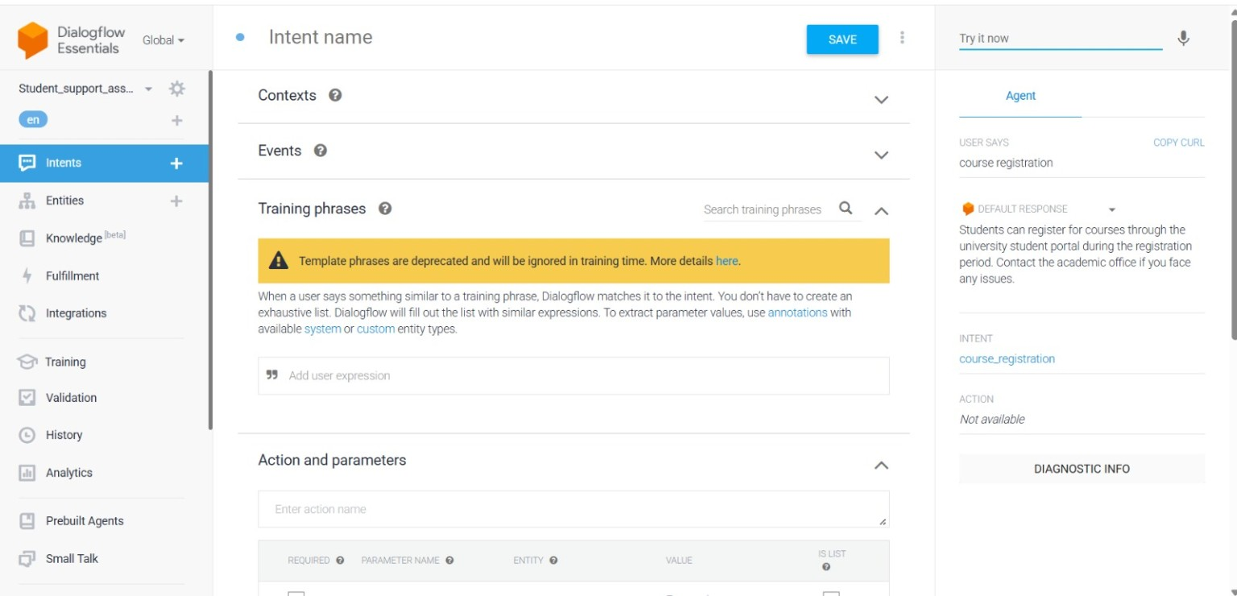
Figure 2: Time Table

